Script for applying the Trial Monitoring & Managing activities

We need to do the following

* Add the Monitoring and Managing details tasks
* Add the singular GDO Departments authorizations
* Remove the overall GDO Authorizations

**Add the Monitoring and Managing details tasks**

Open a work package

1. Type the word “Add_” in the search bar
2. Click on the Action menu next to ADD_TS_Trial_Monitoring
3. Click on the icon at the end of Work and Assignments (this will open to a new window)

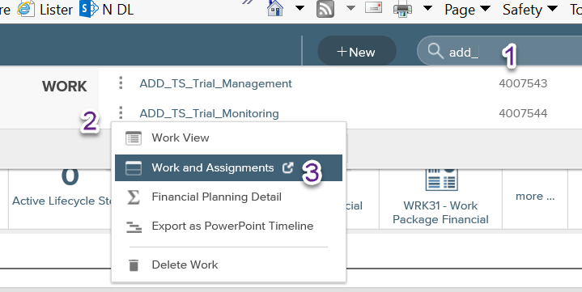

1. Search for the WP you want to update
2. Click on the ***Action*** menu next to it
3. Click on ***Work and Assignments*** (not the icon at the end – will open in the same window)

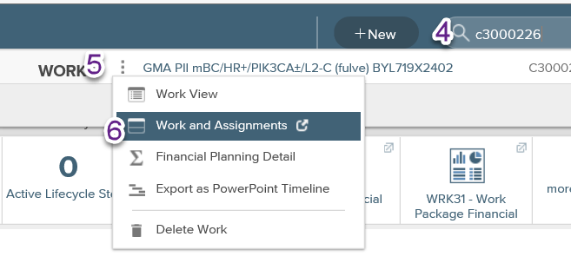

1. Click at the top on the window that has the template.

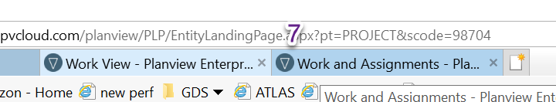

1. Click on the ***Action menu*** next to the line Trial Monitoring Timesheet Activity list
2. Click on Copy

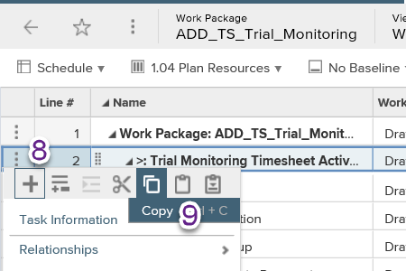

1. Toggle back to the window with the selected WP
2. Click on the ***Action item*** next to line *Time Reporting Summary* **or** *Time Reporting (Summary)*
3. Click on the ***Paste*** icon

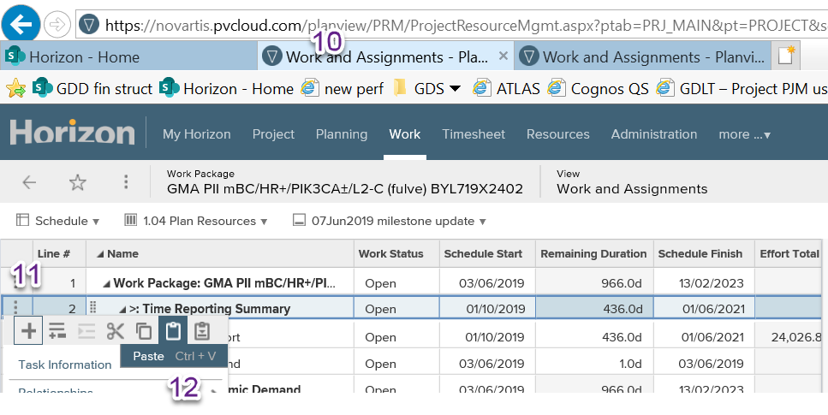

1. Click on the ***Save*** button

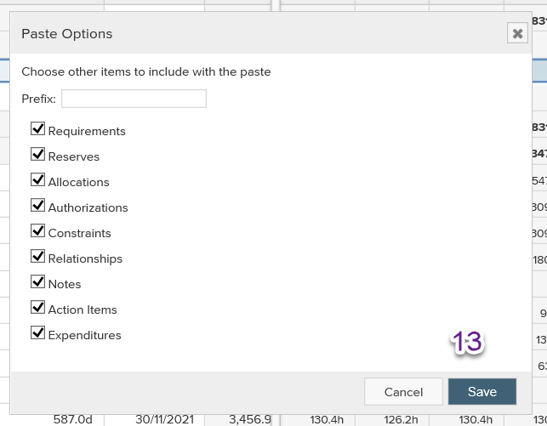

1. Repeat these steps (1-3 & 7-13) for the ADD_TS_Trial_Management

**Add the singular GDO Departments authorizations**

1. Click on the ***Time Report*** line or ***Time Reporting*** line
2. Select ***Task Information***

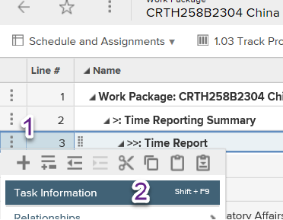

1. Click on **Authorize**
2. Click on ***+Authorization***

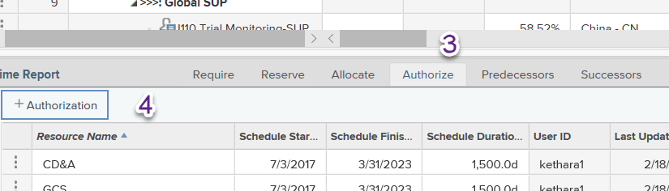

1. Click on ***Search***
2. Enter the 4 character code (do all the ones below)
3. Press the ***Search*** Button
4. Tick the box
5. Click on the ***OK*** Button

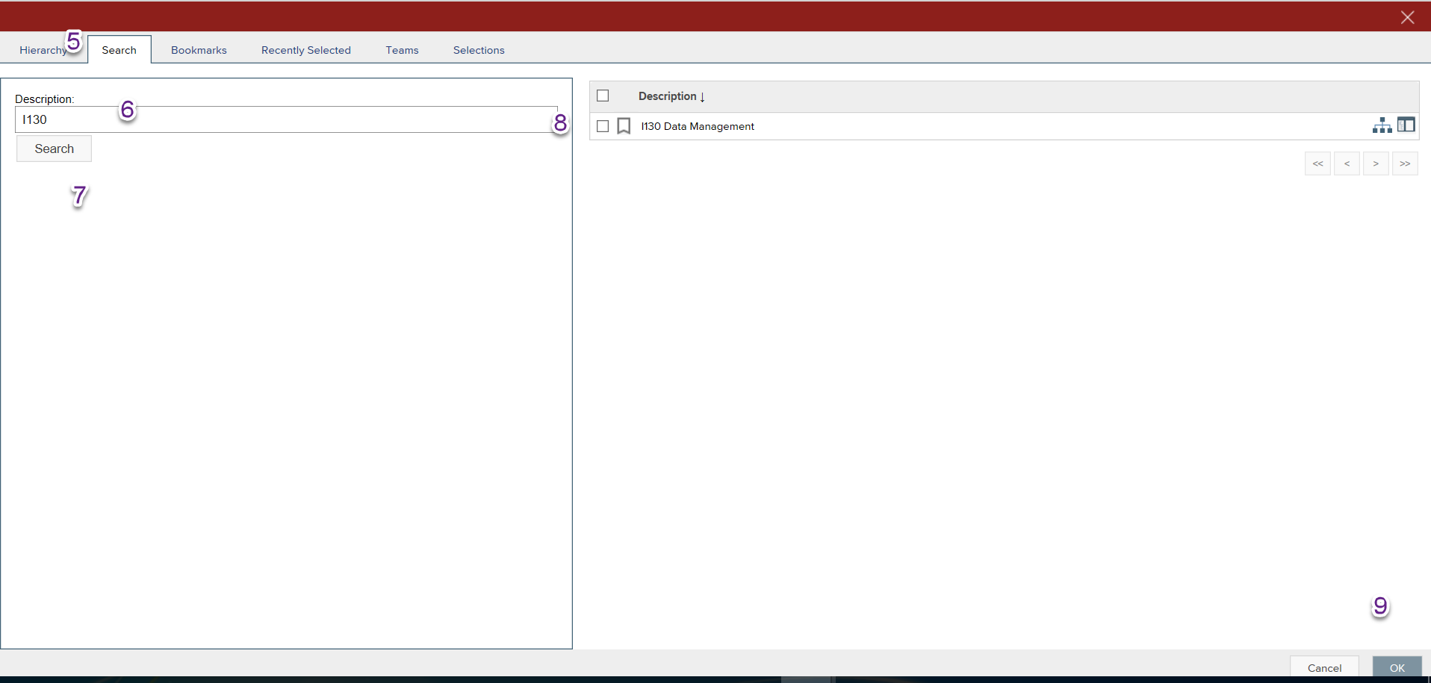

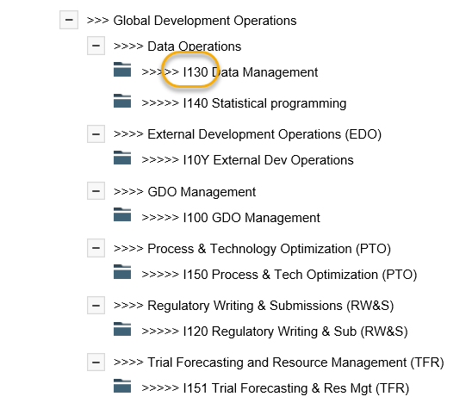

**Remove the overall GDO Authorizations**

1. Click on the ***Schedule*** down arrow
2. Select the **Schedule and Assignments** menu

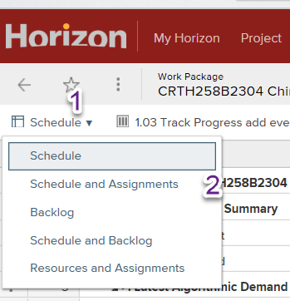

1. Click on the ***Action menu*** next to **Global Development Operations**
2. Click on ***Delete***

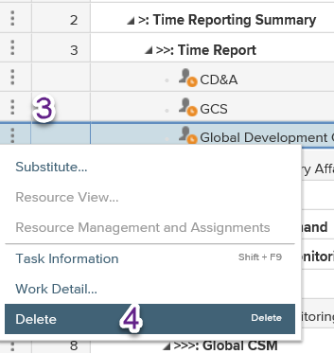

1. At the prompt select ***Yes***

